Probabilistic reasoning

There are a number of ways of using probability to handle uncertainty:

* Bayesian networks
* Decision theory
* Markov Decision Processes

The formalisms are static and so have limited ability to handle changing information.

Bayesian networks can handle such dynamic situations.

States and Observations

The approach we’ll look at considers the world to be a series  
of time slices.  
Each slice contains some variables:  
The set Xt which we can’t observe; and  
The set Et which we can observe.  
Note that Xt and Et are bold to indicate that they may be sets  
of variables.  
At a given point in time we have an observation Et “ et .  
That is we have values for all the variables in Et  
What would be an example?

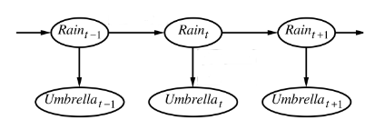

Filtering

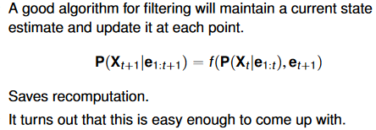

Prediction

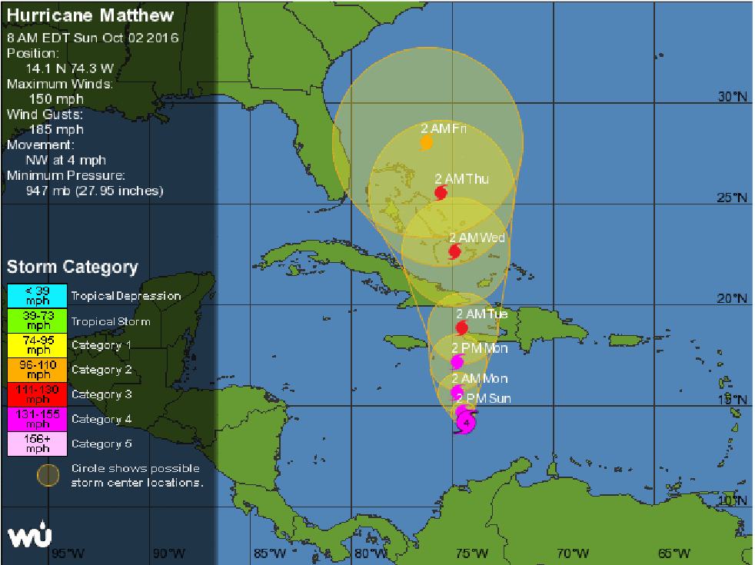wunderground.com